Master Theorem

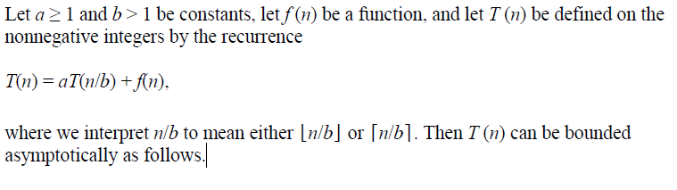

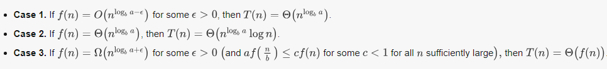

In each of the three cases, we are comparing the function *f* (*n*) with the function  . Intuitively, the solution to the recurrence is determined by the larger of the two functions.

If, as in case 1, the function $n^{\log_{b}{a}}$ is the larger, then the solution is $θ\left(n^{\log_{b}{a}}\right)$

If, as in case 3, the function *f* (*n*) is the larger, then the solution is *T* (*n*) = Θ(*f* (*n*)).

If, as in case 2, the two functions are the same size, we multiply by a logarithmic factor, and the

solution is $θ\left(n^{\log_{b}{a}}\log{n}\right)$

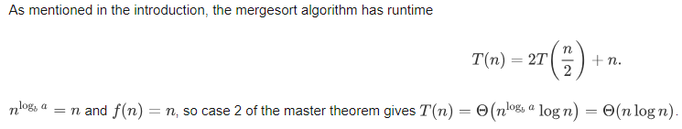

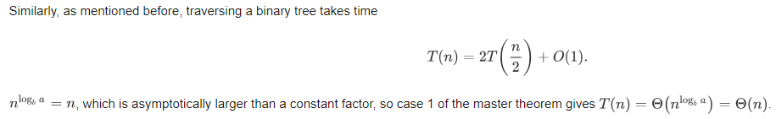

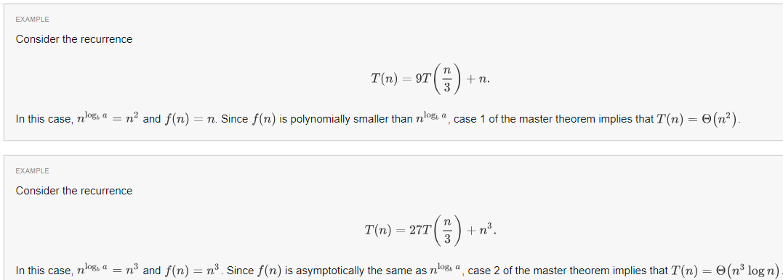

$$\log_{b}{a}=\frac{\log_{c}{a}}{\log_{c}{b}}$$

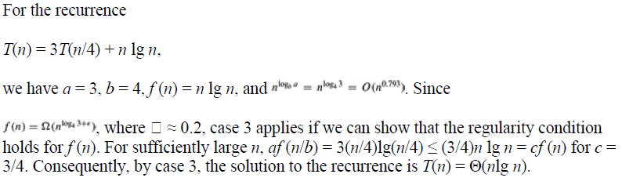

$$af\left(\frac{n}{b}\right)≤cf\left(n\right)$$

$$3f\left(\frac{n}{4}\right)≤c nlgn$$

F(n)=nlgn 🡺 f(n/4)=n/4lgn/4

$$3f\left(\frac{n}{4}\right)≤c nlgn$$

$$3\frac{n}{4}\log{\frac{n}{4}}≤c nlgn$$

$3\frac{n}{4}\lg{\frac{n}{4}}≤c nlgn$ where c=3/4

T(n) = Ꝋ (f(n)) = Ꝋ(nlgn)

The recurrence for Binary Search procedures is therefore

*T (n)* = *T (n/*2*)* + Ꝋ (1) whose solution is *T (n)* = Ꝋ(lgn)

**Solve the following recurrences**

***T* (*n*) = 9*T*(*n*/3) + *n*.**

***T* (*n*) = *T* (2*n*/3) + 1,**

***T* (*n*) = 4*T*(*n*/2) + *n***

***T* (*n*) = 4*T*(*n*/2) + *n*2**

***T* (*n*) = 4*T*(*n*/2) +n3**